**>>Create VPC with 2 private and 2 public subnets.**

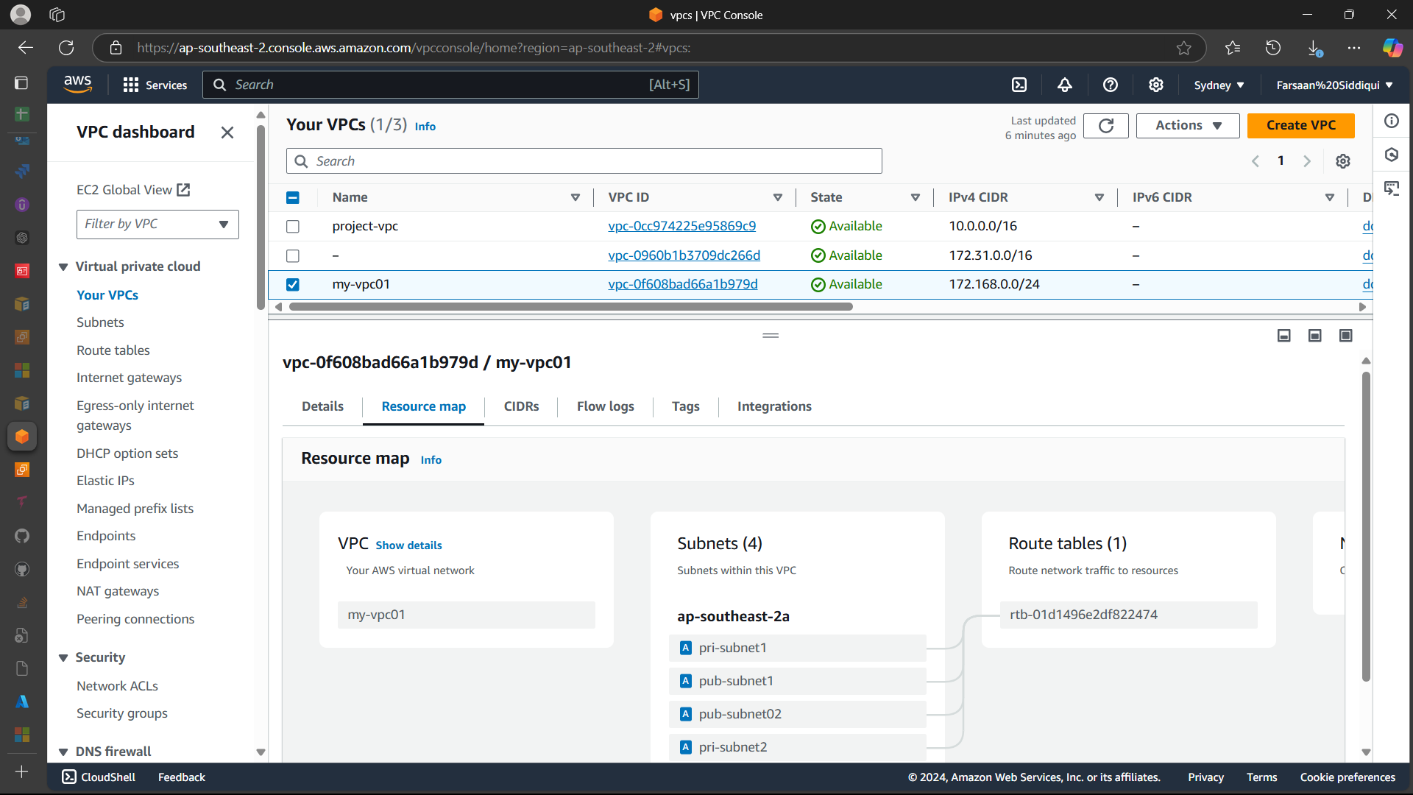

**>>Enable DNS Hostname in VPC**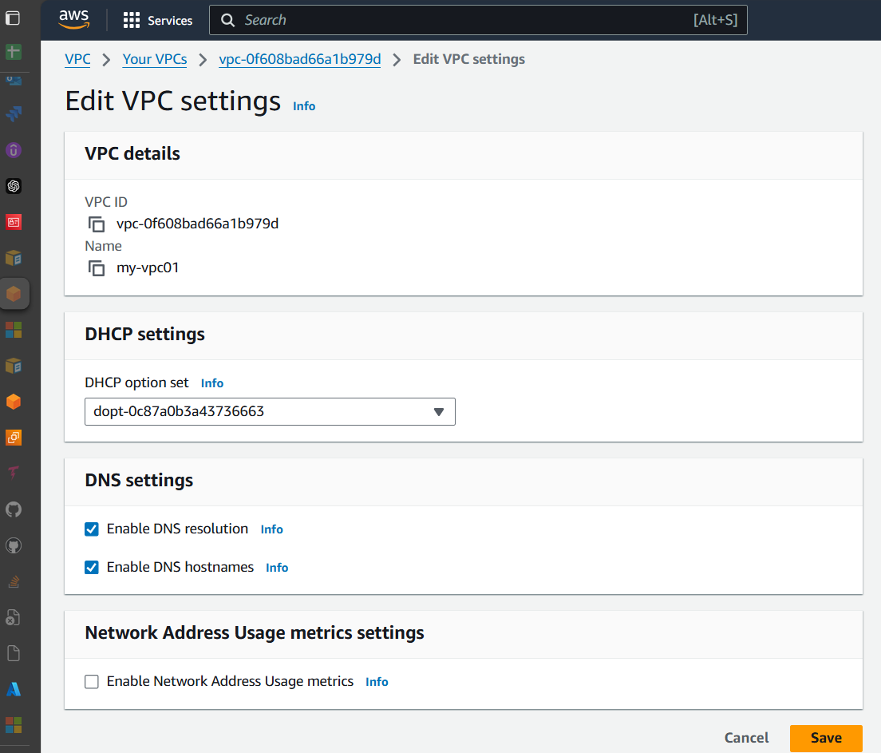

**>>Enable Auto Assign Public ip in 2 public subnets**

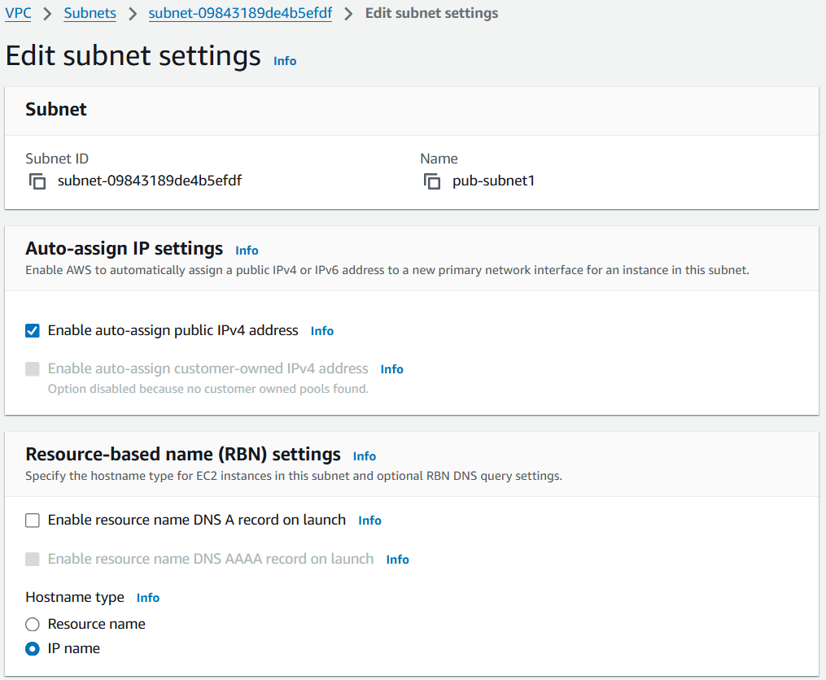

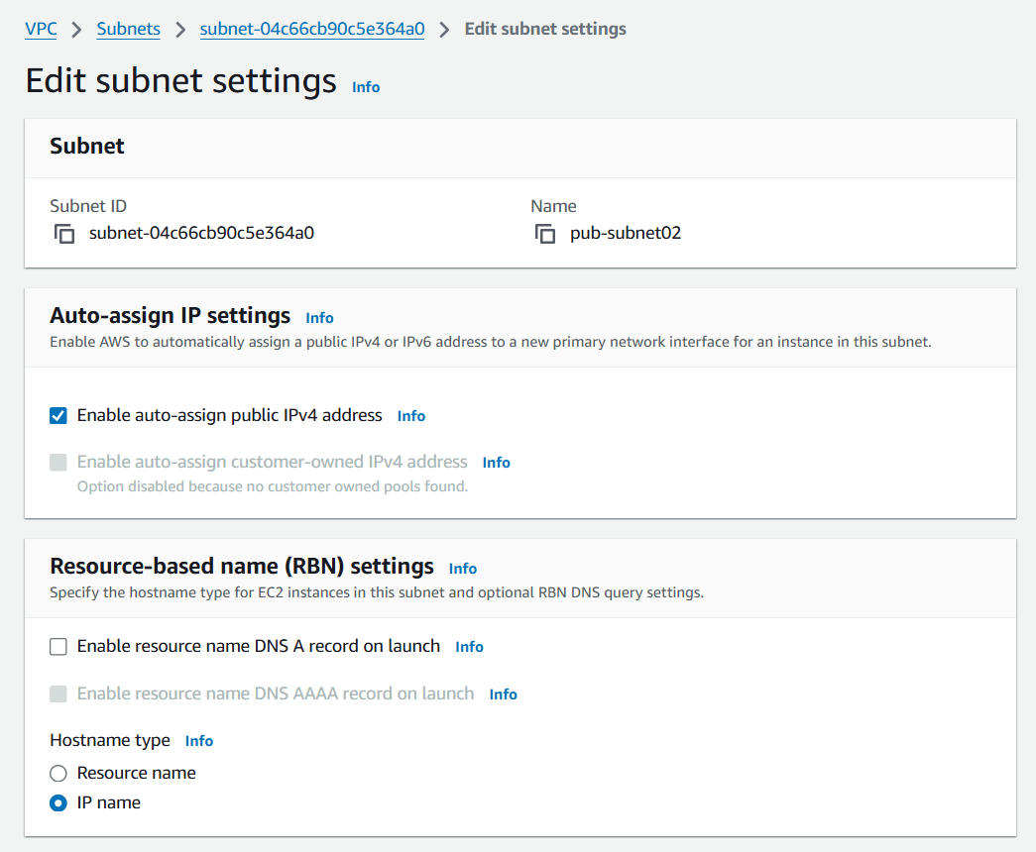

**>>Add 2 private subnets in private route table**

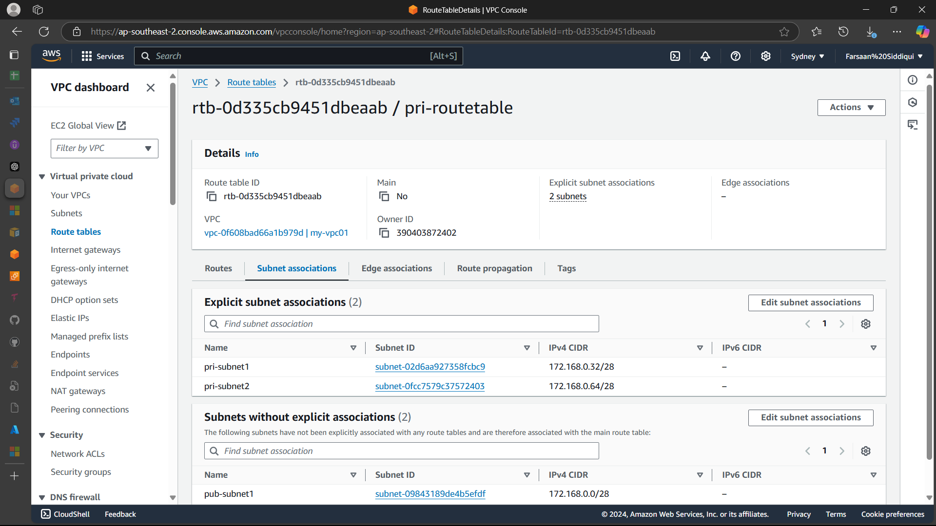

**>>Add 2 public subnets in public route table**

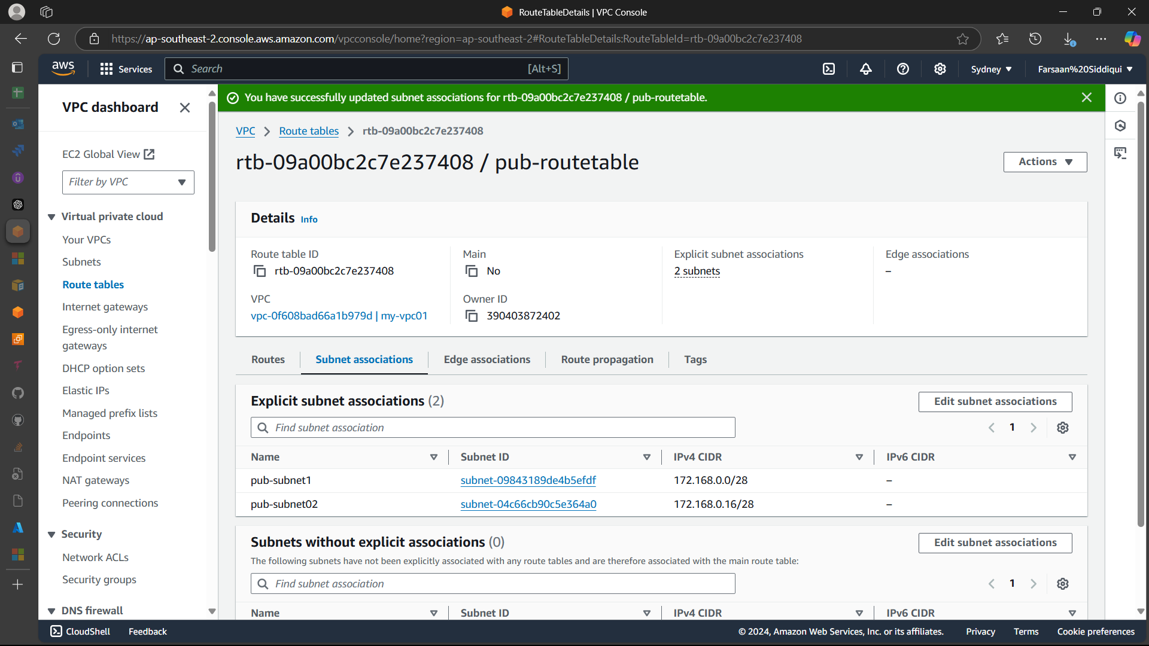

**>>Public route table will have the routes to internet and local**

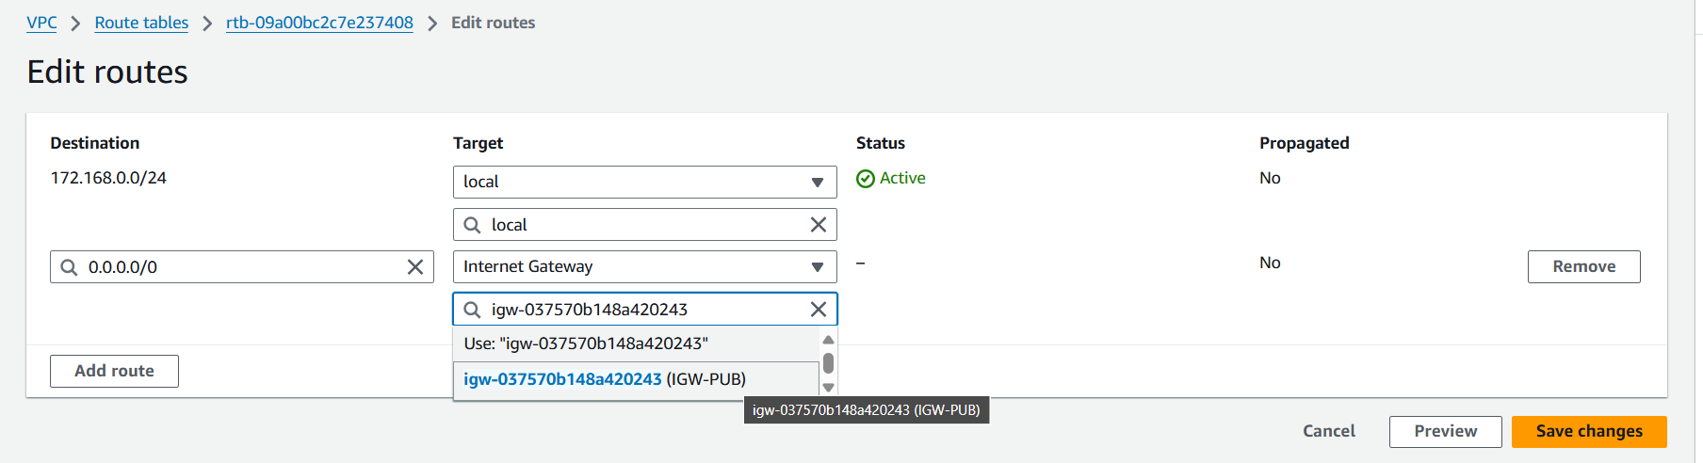

**----------------------------------------------------------------------------------------------------------**

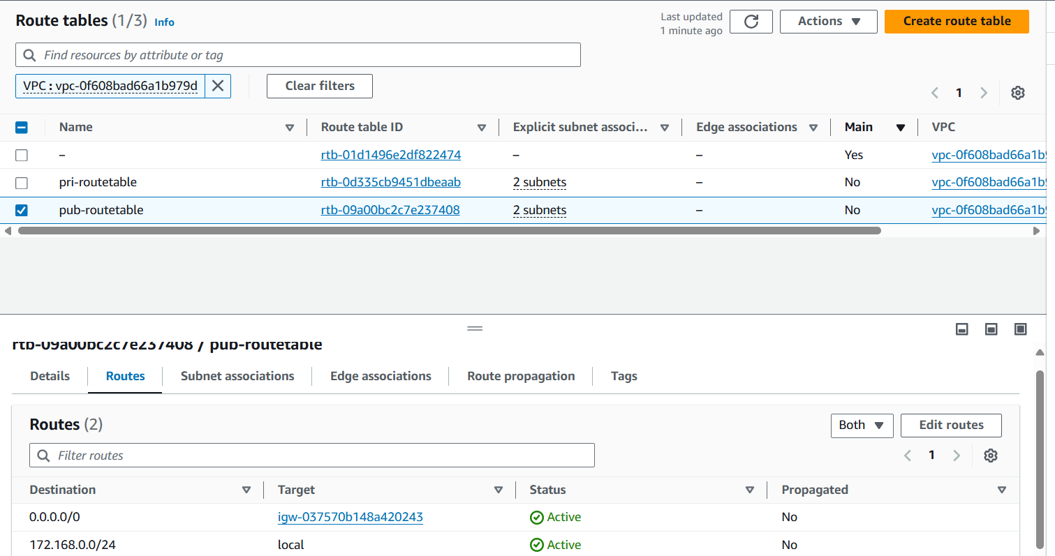

**>>Create Ec2 in public subnet with t2micro and install php**

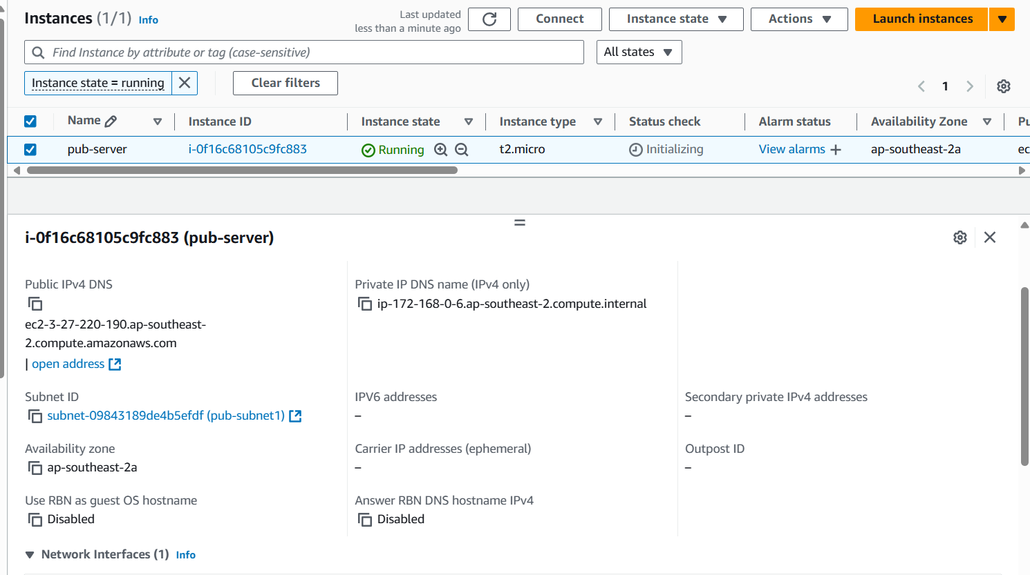

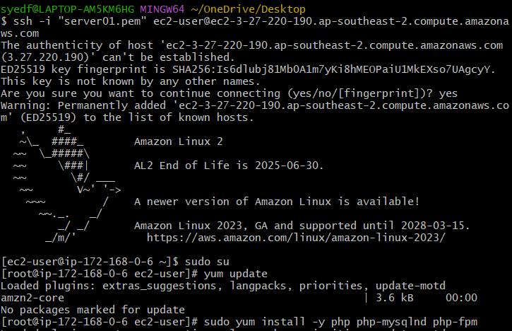

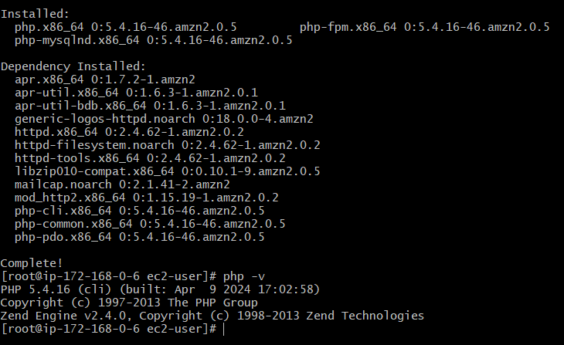

**>>COnfigure Nat gateway in public subnet and connect to private Instance**

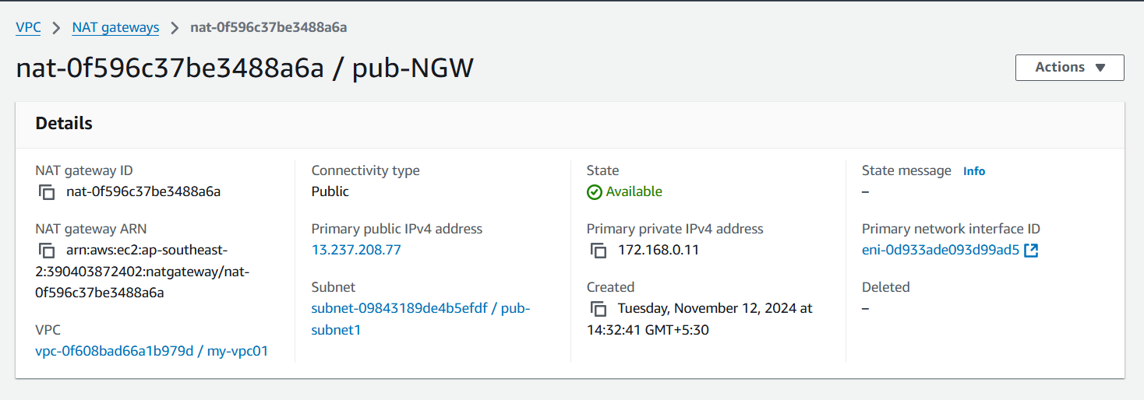

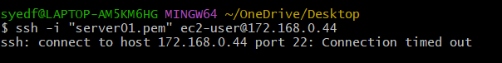

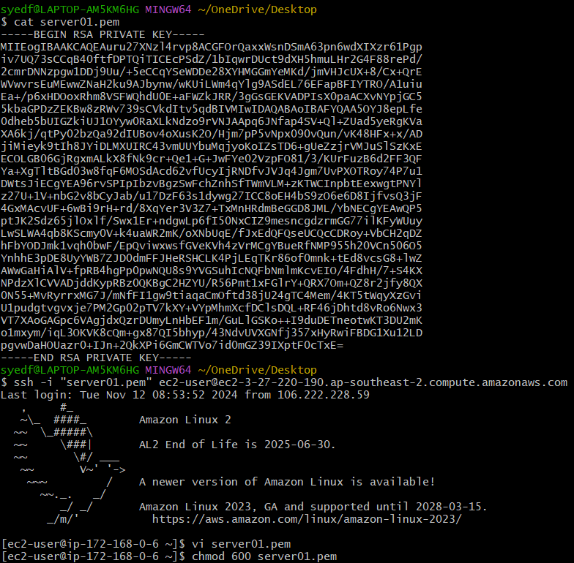

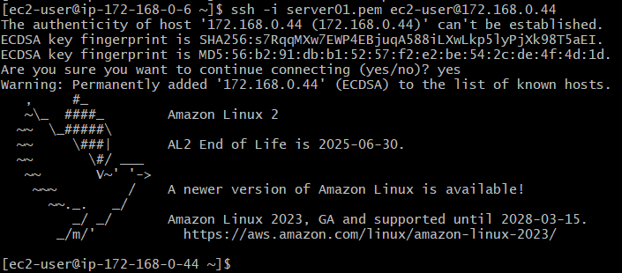

**>>Install Apache Tomcat in private ec2 and deploy a sample app.**

To access internet o private subnet

Go to routes > private routes > add routes > add the nat gateway that is created.

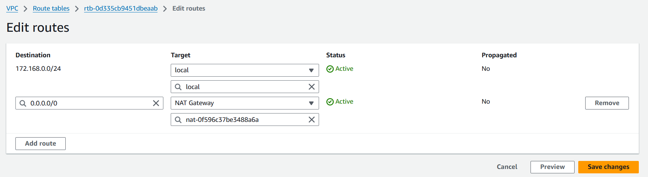

Update system

Sudo yum install java

Sudo wget <tomcat url>

Extract the zip file then start the service from apache-tomcat-x.x.x/bin/tomcat

# vi /etc/systemd/system/tomcat.service

2) Add the below content

[Unit]  
Description=Tomcat - instance %i  
After=syslog.target network.target[Service]  
Type=forkingUser=root  
Group=rootExecStart=/opt/apache-tomcat-9.0.78/bin/startup.sh    #check the path of startup.sh  
ExecStop=/opt/apache-tomcat-9.0.78/bin/shutdown.sh    #check the path of shutdown.shRestartSec=10  
Restart=always3)Restart Daemon  
# systemctl daemon-reload4) Start tomcat using systemctl.  
# systemctl start tomcat

<**to start/stop/enable/disable service with systemctl**>

**>>COnfigure VPC flow logs and store the logs in s3 and cloudwatch.**

